For #1-4, write the equation represented by each graph. (Note: A values are either 1 or -1 only)
1) 2) 3) 4)

- Complete the following for each function.
$f(x)=2(x−2)^{2}+3$ $f(x)=\sqrt{x+3}−4$ $f(x)=\frac{1}{x−4}−1$

Domain: ________________ Domain: ________________ Domain: ________________

Range: _________________ Range: _________________ Range: _________________

- Write the quadratic function$f(x)=−2x+8x−3$ in standard/vertex form. $f(x)=$____________________

- Identify all of the following for the quadratic function: $f(x)=x^{2}−6x+8$
Vertex is a Axis of
Vertex @ ___________ MAX or MIN Symmetry @ ____________ x-int @ __________ y-int @ _________
(circle one)

- Sketch the graph of the piecewise-defined function. 9) Write the equation of the piecewise-defined function.
Be sure to label the coordinates (x, y) of all Be sure to include domains for each equation.
endpoints of the graph.

$$f\left(x\right)=\begin{aligned}\left\{\sqrt{−x}, (−∞, 0) | \right.\left\{\frac{1}{2}x−4, [0, 6) | \right.\end{aligned}$$
- ____________

- ____________

- ____________

- ____________

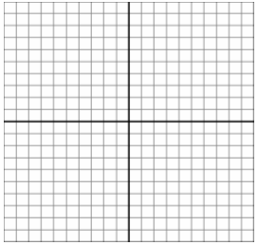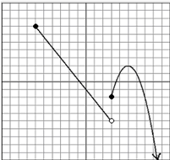

$$f\left(x\right)=\begin{aligned}\left\{ | \right.\left\{\text{____________________} | \right.\left\{ | \right.\end{aligned}$$

This Pretest is to be completed as preparation for the Unit Test and will be graded as a section of this test.
Collaboration with classmates is permitted, but copying work is considered cheating and will result in a zero.
The use of class notes is not permitted to complete this assignment.
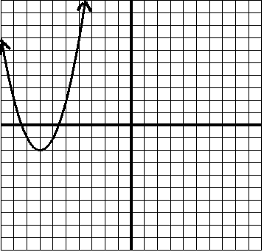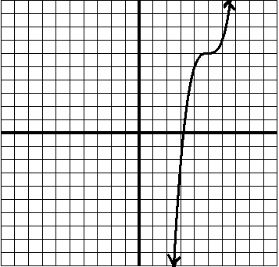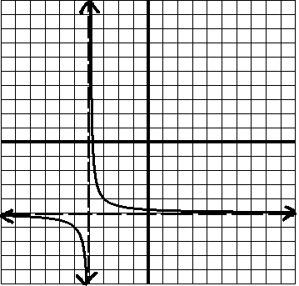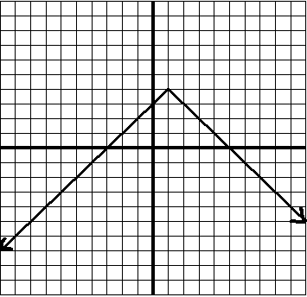

Vertex @ Vertex @ Vertex @

________ ________ ________

